**GOVERNMENT COLLEGE OF ENGINEERING**

**CHETTIKARAI,DHARMAPURI**

**DEEP LEARNING FUNDUS IMAGE  ANALYSIS FOR EARLY   DETECTION OF   DIABETIC RETINOPATHY**

**IBM - NALAIYA THIRAN**

**Project Report**

|  |  |
| --- | --- |
| **TITLE** | DEEP LEARNING FUNDUS IMAGE     ANALYSIS EARLY FOR   DETECTION OF   DIABETIC RETINOPATHY |
| **DOMAIN NAME** | ARTIFICIAL INTELLIGINECE |
| **TEAM ID** | PNT2022TMID4355 |
| **TEAM LEADER NAME** | NARMADHA.R |
| **TEAM MEMBERS NAME** | SOUNDHARYA.B  FARIZA.A  MADHUBALA.K |
| **MENTOR NAME** | DINESH GANESAN |

**1.INTRODUCTION**

**1.1 Project Overview**:

Diabetic retinopathy (DR) is one of the most complicated issues of diabetic patients in which the retina becomes damaged and leads to blindness. It affects the blood vessels in the retina and due to leakage of fluid distort the vision completely. DR progress through mainly four stages;

The stages are Mild , Moderate and Severe retinopathy.

Each and every stage has its own characteristics and particular properties. But doctors possibly could not take some of them into account and thus make an incorrect diagnosis. So this leads to the idea of creation of an automatic solution for DR detection. DR can lead to a loss of vision if it is in an advanced stage. Worldwide, DR causes 2.6% of blindness. The possibility of DR presence increases for diabetes patients who suffer from the disease for a long period. Retina regular screening is essential for diabetes patients to diagnose and to treat DR at an early stage to avoid the risk of blindness. DR is detected by the appearance of different types of lesions on a retina image. These lesions are micro-aneurysms (MA), hemorrhages (HM), soft and hard exudates (EX).

**1.2 Purpose**:

* The main objective is the early detection of diabetic retinopathy to prevent vision loss.
* To overcome the disadvantages of manual diagnosis.
* To save time and reduce the risk of misdiagnosis

**2. LITERATURE SURVEY**

* DR detection using prognosis of microaneurysm.
* Predicting DR at early stages is a challenge for decades.
* Affected by prolonged increased level
* Deep Learning provides solution for medical analysis problems
* The presence of microaneurysm in fundus using CNN algorithm.

**2.2 Reference:**

**Early detection of diabetic retinopathy based on deep learning and ultra-wide-field fundus images**

**Author:** Kangrok oh,Hae min kang,Dawoon Leem,Hyungyu lee

<https://www.nature.com/articles/s41598-021-81539-3>

**Abstract:**

Visually impaired and blind people due to diabetic retinopathy were 2.6 million in 2015 and estimated to be 3.2 million in 2020 globally. Though the incidence of diabetic retinopathy is expected to decrease for high-income countries, detection and treatment of it in the early stages are crucial for low-income and middle-income countries. Due to the recent advancement of deep learning technologies, researchers showed that automated screening and grading of diabetic retinopathy are efficient in saving time and workforce. However, most automatic systems utilize conventional fundus photography, despite ultra-wide-field fundus photography provides up to 82% of the retinal surface. In this study, we present a diabetic retinopathy detection system based on ultra-wide-field fundus photography and deep learning. In experiments, we show that the use of early treatment diabetic retinopathy study 7-standard field image extracted from ultra-wide-field fundus photography outperforms that of the optic disc and macula centered image in a statistical sense.

# Diabetic Retinopathy Detection Using Prognosis of Microaneurysm and Early Diagnosis System for Non-Proliferative Diabetic Retinopathy Based on Deep Learning Algorithms

# Author:Lifeng qiao,Ying zhu,Hui zhou

# <https://ieeexplore.ieee.org/abstract/document/9091167>

# Abstract:

Predicting the presence of Microaneurysms in the fundus images and the identification of diabetic retinopathy in early-stage has always been a major challenge for decades. Diabetic Retinopathy (DR) is affected by prolonged high blood glucose level which leads to micro-vascular complications and irreversible vision loss. Microaneurysms formation and macular edema in the retinal is the initial sign of DR and diagnosis at the right time can reduce the risk of non proliferated diabetic retinopathy. The rapid improvement of deep learning makes it gradually become an efficient technique to provide an interesting solution for medical image analysis problems. The proposed system analysis the presence of microaneurysm in fundus image using convolutional neural network algorithms that embeds deep learning as a core component accelerated with GPU(Graphics Processing Unit) which will perform medical image detection and segmentation with high-performance and low-latency inference. The semantic segmentation algorithm is utilized to classify the fundus picture as normal or infected. Semantic segmentation divides the image pixels based on their common semantic to identify the feature of microaneurysm. This provides an automated system that will assist ophthalmologists to grade the fundus images as early NPDR, moderate NPDR, and severe NPDR. The Prognosis of Microaneurysm and early diagnosis system for non - proliferative diabetic retinopathy system has been proposed that is capable to train effectively a deep convolution neural network for semantic segmentation of fundus images which can increase the efficiency and accuracy of NPDR (non proliferated diabetic retinopathy) prediction.

# Deep Learning based Early Detection and Grading of Diabetic Retinopathy Using Retinal Fundus Images

# Author:Sheikh Muhammad Saiful Islam, Md Mahedi Hasan, Sohaib Abdullah

# <https://arxiv.org/abs/1812.10595>

# Abstract:

# Diabetic Retinopathy (DR) is a constantly deteriorating disease, being one of the leading causes of vision impairment and blindness. Subtle distinction among different grades and existence of many significant small features make the task of recognition very challenging. In addition, the present approach of retinopathy detection is a very laborious and time-intensive task, which heavily relies on the skill of a physician. Automated detection of diabetic retinopathy is essential to tackle these problems. Early-stage detection of diabetic retinopathy is also very important for diagnosis, which can prevent blindness with proper treatment. In this paper, we developed a novel deep convolutional neural network, which performs the early-stage detection by identifying all microaneurysms (MAs), the first signs of DR, along with correctly assigning labels to retinal fundus images which are graded into five categories. We have tested our network on the largest publicly available Kaggle diabetic retinopathy dataset, and achieved 0.851 quadratic weighted kappa score and 0.844 AUC score, which achieves the state-of-the-art performance on severity grading. In the early-stage detection, we have achieved a sensitivity of 98% and specificity of above 94%, which demonstrates the effectiveness of our proposed method. Our proposed architecture is at the same time very simple and efficient with respect to computational time and space are concerned.

**2.3 Problem Statement Definition**

* Diabetic Retinopathy (DR) is a common complication of diabetes mellitus, which causes lesions on the retina that affect vision
* If it is not detected early, it can lead to blindness. Unfortunately, DR is not a reversible process, and treatment only sustains vision.
* DR early detection and treatment can significantly reduce the risk of vision loss.
* The manual diagnosis process of DR retina fundus images by ophthalmologists is time, effort and cost-consuming and prone to misdiagnosis unlike computer-aided diagnosis systems.
* Transfer learning has become one of the most common techniques that has achieved better performance in many areas, especially in medical image analysis and classification. We used Transfer Learning techniques like Inception V3,Resnet50,Xc…

**3. IDEATION & PROPOSED SOLUTION**

**3.1 Empathy Map Canvas**

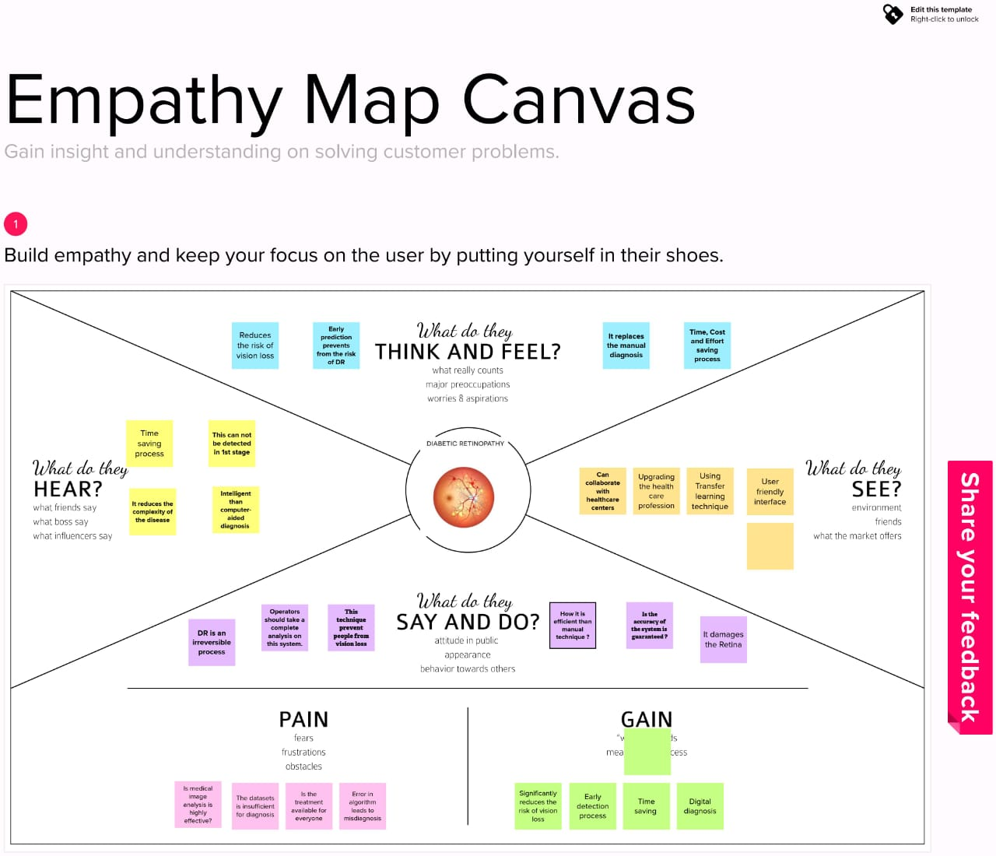

**3.2 Ideation & Brainstorming**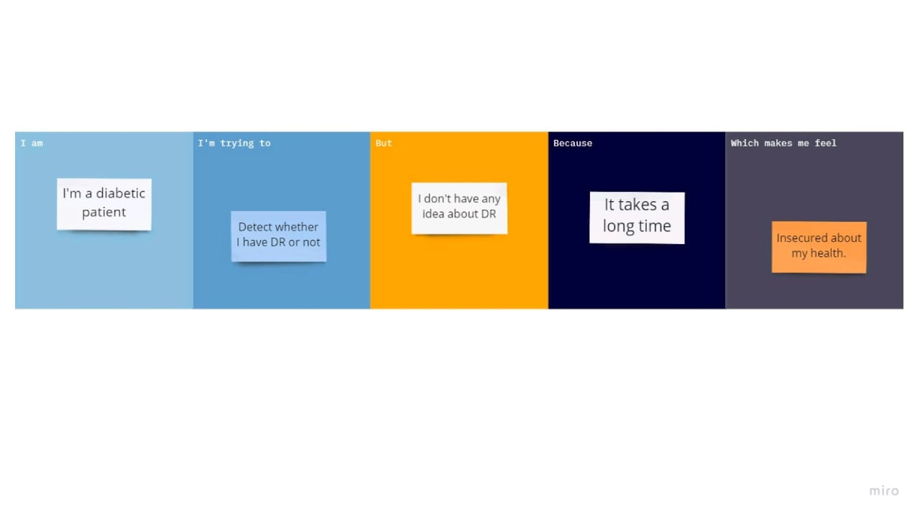

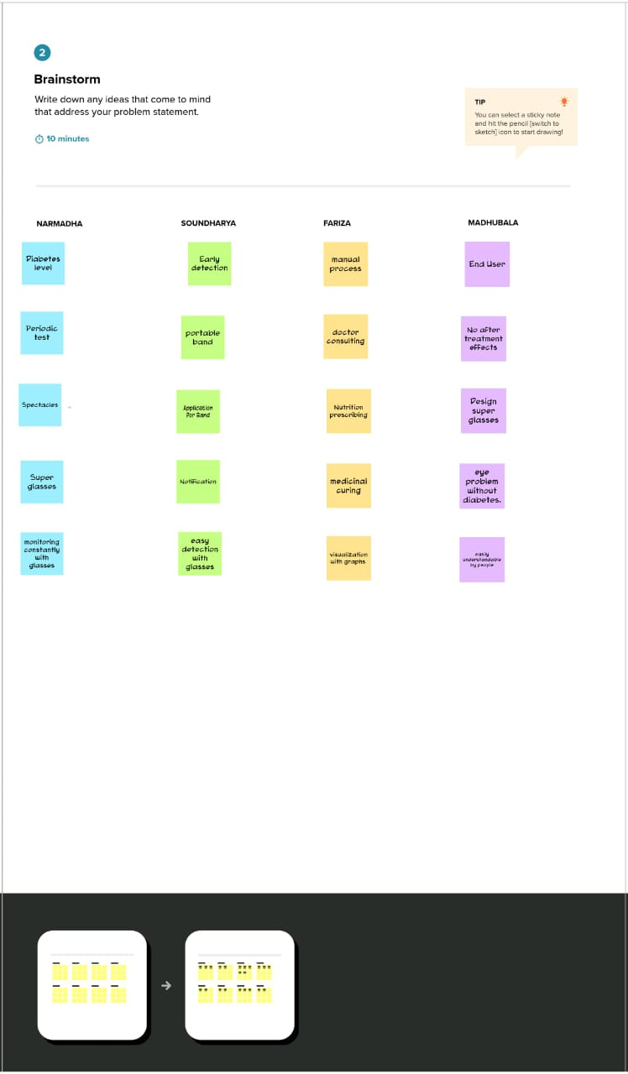

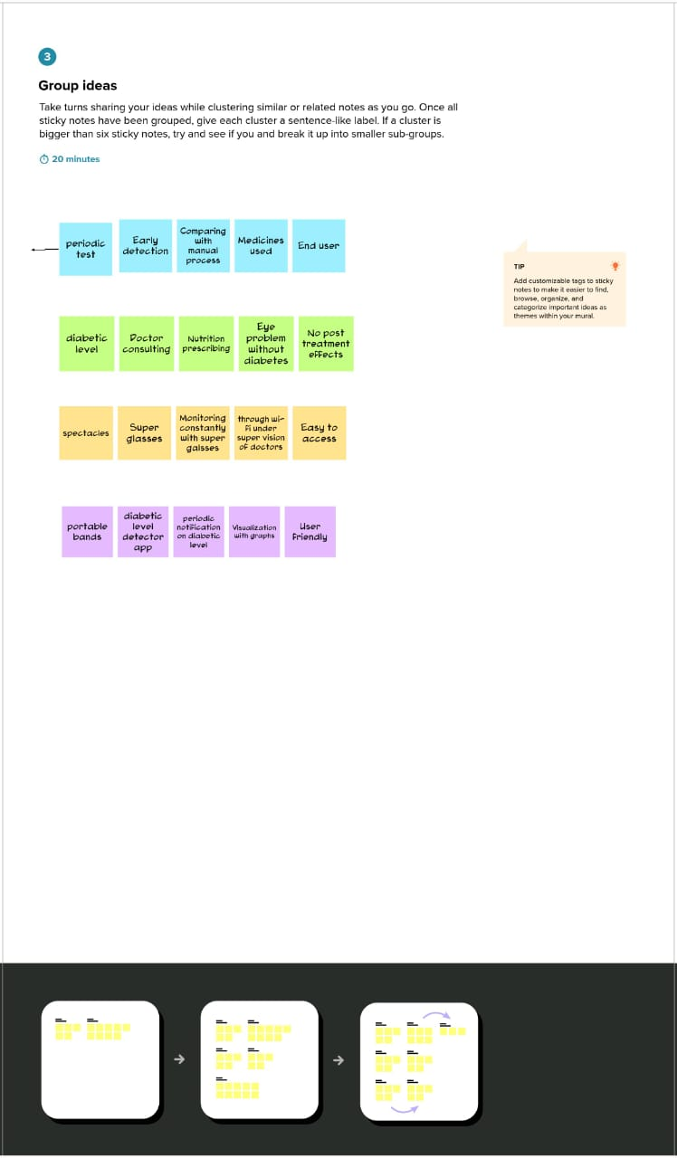

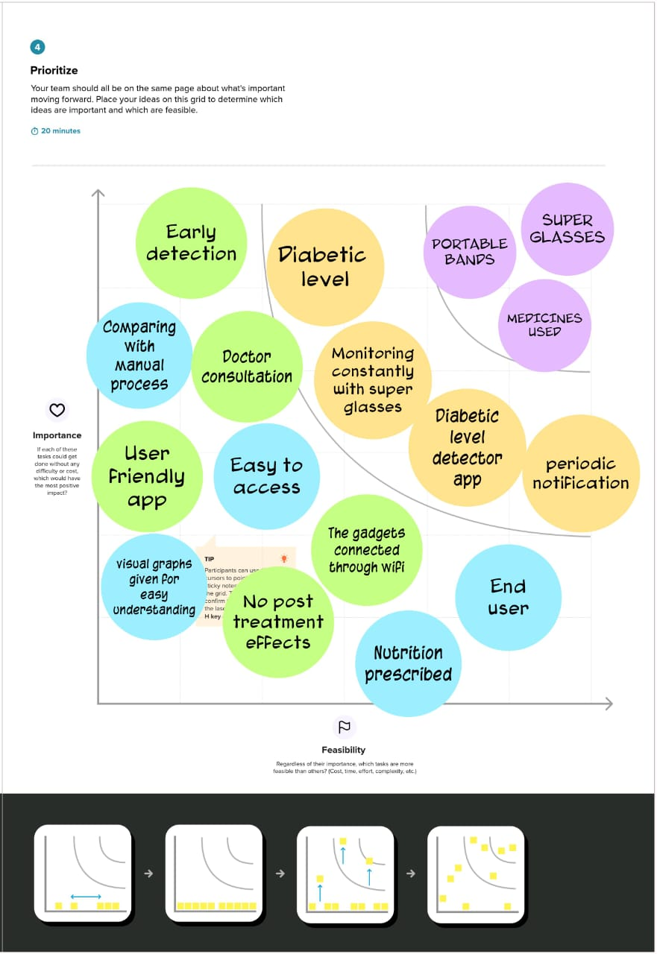

**3.3 Proposed Solution**

|  |  |  |  |
| --- | --- | --- | --- |
| S.NO | PARAMETERS | | DESCRIPTION |
| 1. | Problem statement(problem to be solved) | | Early detection of diabetic retinopathy to reduce the risk of vision loss. |
| 2. | Idea/solution description | | Detecting diabetic retinopathy at early stages using deep learning fundus image analysis. |
| 3. | Novelty/uniqueness | | Images of eye were taken by the operator and analysis done with database. |
| 4. | Social impact/customer statisfaction | | It reduces the extremity of damaging retina of the eye that leads to blindness. |
| 5. | Business model  (revenue model) | | Can collaborate with diagnosis centers and hospitals to analyse patients more precisely. |
| 6. | Scalability of the solution. | Can collaborate with government for health care. | |

**3.4 Problem Solution Fit**

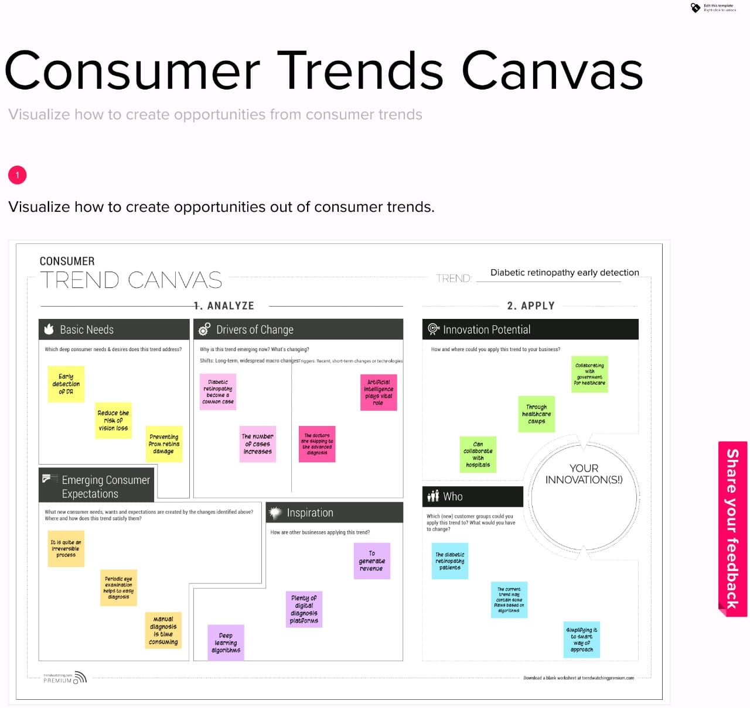

**4. REQUIREMENT ANALYSIS**

**4.1 Functional Requirement:**

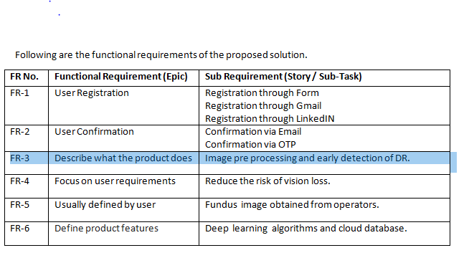

**4.2 Non Functional Requirements**

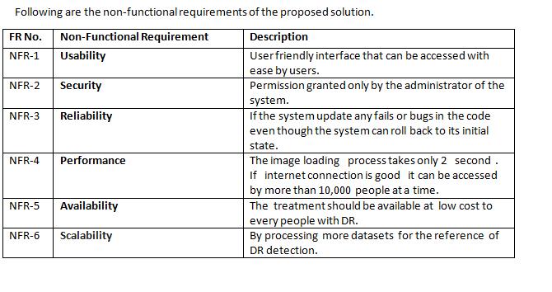

5. PROJECT DESIGN PHASE

**5.1 Data Flow Diagram:**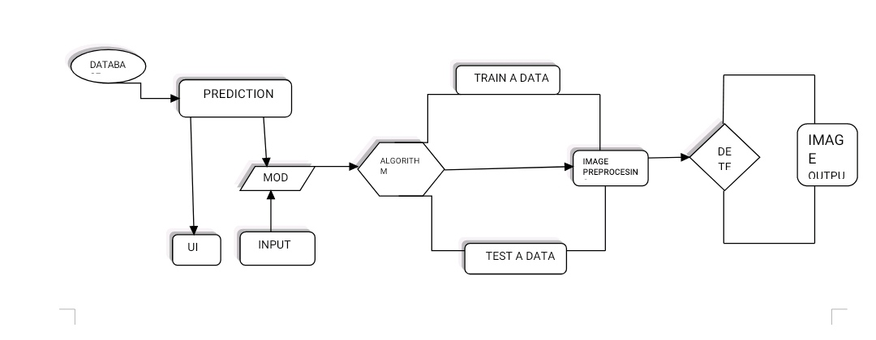

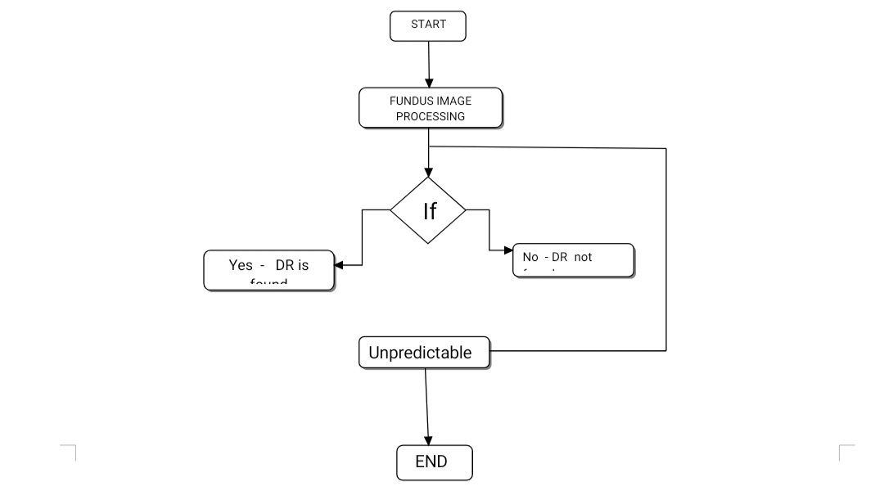

5.2 Solution and Technical Architecture



5.3 User stories:

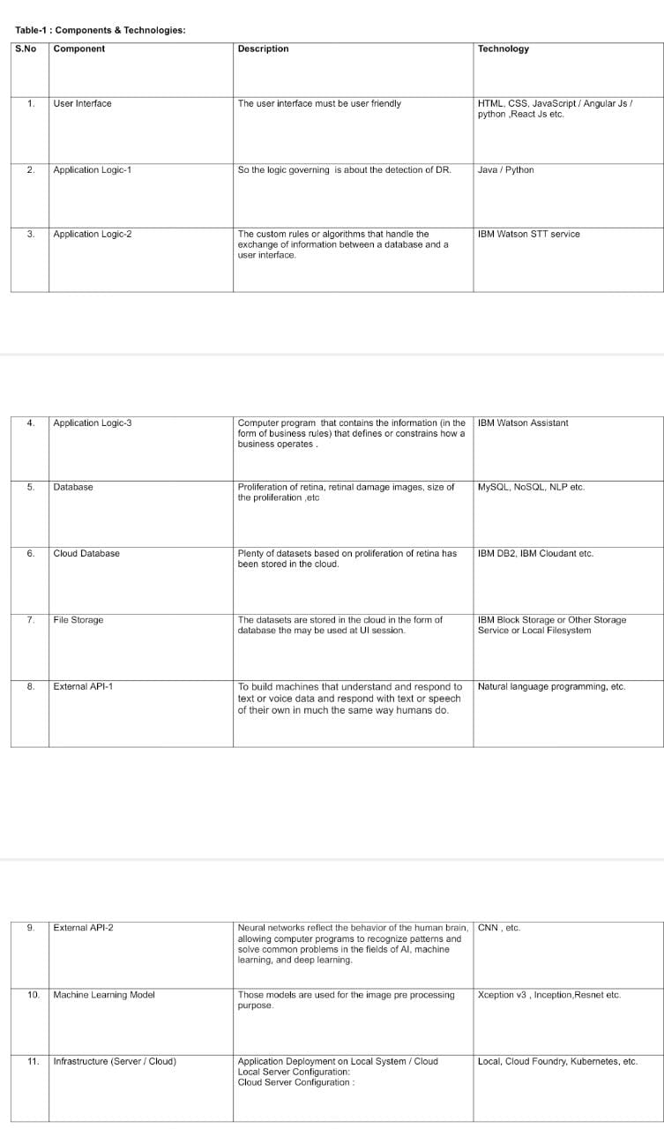

**6.PROJECT PLANNING AND SCHEDULING**

6.1 Sprint planning&Estimation:

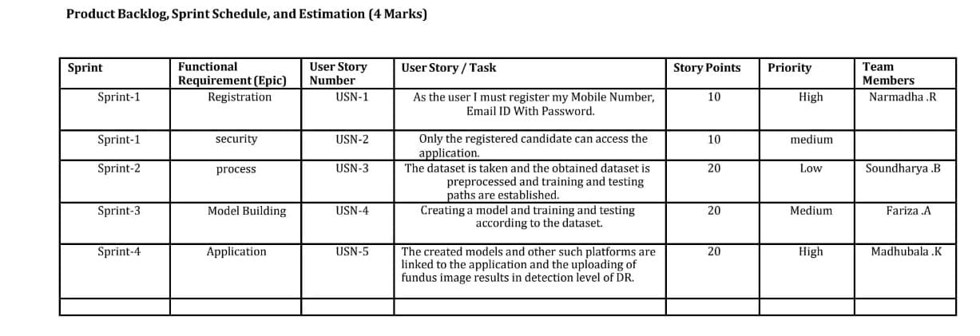

6.2 Sprint Delivery Schedule:

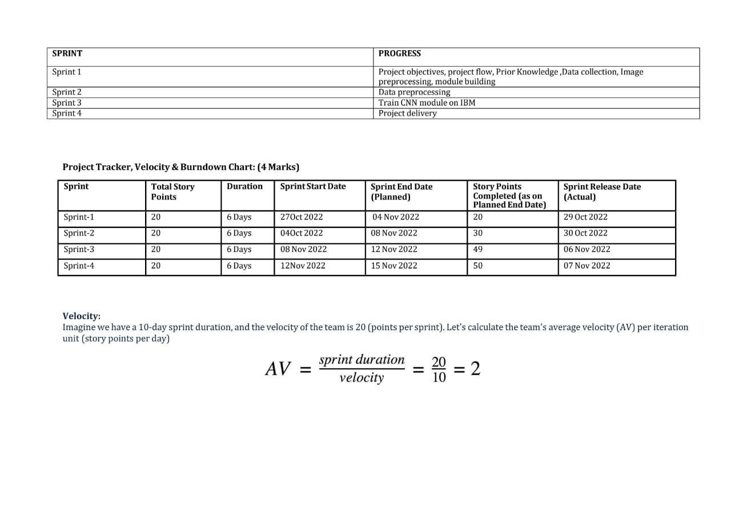

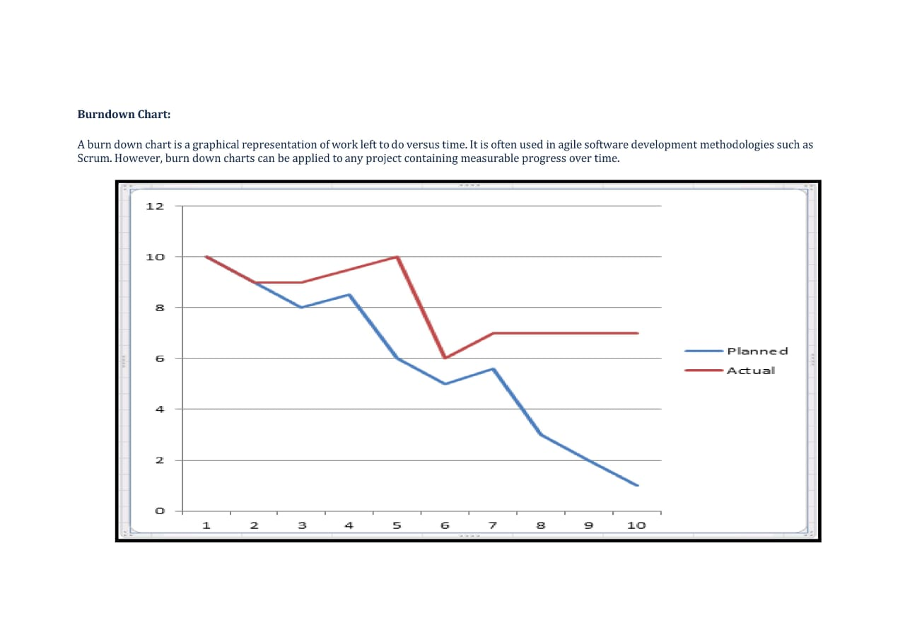

**7.CODING & SOLUTIONING**

**7.1 Feature 1:**

**Feature 1:**

Can build,train and save the model.

**Code segment**:

from tensorflow.keras.layers import Dense,Flatten,Input

from tensorflow.keras.models import Model

IMPORTING LIBRARIES

from tensorflow.keras.preprocessing import image

from tensorflow.keras.preprocessing.image import ImageDataGenerator,load_img

from tensorflow.keras.applications.xception import Xception,preprocess_input

from glob import glob

import numpy as np

import matplotlib.pyplot as plt

!pip install tensorflow.gpu

!pip install keras

CONFIGURE IMAGE GENERATOR CLASS

train_datagen=ImageDataGenerator(rescale=1./255,

shear_range=0.2,

zoom_range=0.2,

horizontal_flip=True)

test_datagen=ImageDataGenerator(rescale=1./255)

MODEL BUILDING

xception = Xception(input_shape=imageSize + [3],weights='imagenet',include_top=False)

#dont train existing weight

for layer in xception.layers:

layer.trainable = False

#our layers-you can add moreif you want

x = Flatten()(xception.output)

ADDING DENSE LAYERS

prediction = Dense(5, activation='softmax')(x)

#create a model object

model = Model(inputs=xception.input, outputs=prediction)

#view the structure of the model

model.summary()

CONFIGURE THE LEARNING PROCESS

#tell the model what cost and optimization method to use

model.compile(

loss='categorical_crossentropy',

optimizer='adam',

metrics = ['accuracy']

)

TRAIN THE MODEL

#fit the model

r = model.fit_generator(

trainset,

validation_data=test_set,

epochs=30,

steps_per_epoch=len(training_set)//32,

validation_steps=len(test_set)//32

)

SAVE THE MODEL

model.save('updated-Xception-diabetic-retinopathy.h5')

**7.2 Feature 2:**

**Feature:**

Can used to build the HTML page with home,index,register,login,logout and prediction pages

**Code segment:**

INDEX PAGE

<!DOCTYPE html>

<html lang="en">

<head>

<meta charset="UTF-8" />

<meta http-equiv="X-UA-Compatible" content="IE=edge" />

<meta name="viewport" content="width=device-width, initial-scale=1.0" />

<!-- CSS only -->

<link

href="https://cdn.jsdelivr.net/npm/bootstrap@5.2.1/dist/css/bootstrap.min.css"

rel="stylesheet"

integrity="sha384-iYQeCzEYFbKjA/T2uDLTpkwGzCiq6soy8tYaI1GyVh/UjpbCx/TYkiZhlZB6+fzT"

crossorigin="anonymous"

/>

<!-- JavaScript Bundle with Popper -->

<script

src="https://cdn.jsdelivr.net/npm/bootstrap@5.2.1/dist/js/bootstrap.bundle.min.js"

integrity="sha384-u1OknCvxWvY5kfmNBILK2hRnQC3Pr17a+RTT6rIHI7NnikvbZlHgTPOOmMi466C8"

crossorigin="anonymous"

></script>

<style>

#navbarRight {

margin-left: auto;

padding-right:10px;

}

.navbar-brand{

padding-left:15px;

}

</style>

<title>DR Predcition</title>

</head>

<body>

<nav class="navbar navbar-expand-lg navbar-light bg-dark">

<div>

<a class="navbar-brand" href="#" style="color:aliceblue">Diabetic Retinopathy Classification</a>

</div>

<div class="navbar-collapse collapse w-100 order-3 dual-collapse2" id="navbarNav">

<ul class="navbar-nav mr-auto text-center" id="navbarRight">

<li class="nav-item active">

<a class="nav-link" href="index" style="color: aliceblue;">Home </a>

</li>

<li class="nav-item">

<a class="nav-link" href="login" style="color: aliceblue;">Login</a>

</li>

<li class="nav-item">

<a class="nav-link" href="register"style="color: aliceblue;">Register</a>

</li>

<li class="nav-item">

<a class="nav-link" href="predict"style="color: aliceblue;">Prediction</a>

</li>

</ul>

</div>

</nav>

<div class="d-flex justify-content-center">

<img style="width:70vw;" src="static/diabetic-retinopathy-home.jpg">

</div>

</body>

</html>

LOGIN PAGE

<!DOCTYPE html>

<html lang="en">

<head>

<meta charset="UTF-8" />

<meta http-equiv="X-UA-Compatible" content="IE=edge" />

<meta name="viewport" content="width=device-width, initial-scale=1.0" />

<!-- CSS only -->

<link

href="https://cdn.jsdelivr.net/npm/bootstrap@5.2.1/dist/css/bootstrap.min.css"

rel="stylesheet"

integrity="sha384-iYQeCzEYFbKjA/T2uDLTpkwGzCiq6soy8tYaI1GyVh/UjpbCx/TYkiZhlZB6+fzT"

crossorigin="anonymous"

/>

<!-- JavaScript Bundle with Popper -->

<script

src="https://cdn.jsdelivr.net/npm/bootstrap@5.2.1/dist/js/bootstrap.bundle.min.js"

integrity="sha384-u1OknCvxWvY5kfmNBILK2hRnQC3Pr17a+RTT6rIHI7NnikvbZlHgTPOOmMi466C8"

crossorigin="anonymous"

></script>

<style>

#navbarRight {

margin-left: auto;

padding-right:10px;

}

.navbar-brand{

padding-left:15px;

}

</style>

<title>DR Predcition</title>

</head>

<form action="",method='POST'>

<nav class="navbar navbar-expand-lg navbar-light bg-dark">

<div>

<a class="navbar-brand" href="#" style="color:aliceblue">DR Register</a>

</div>

<div class="navbar-collapse collapse w-100 order-3 dual-collapse2" id="navbarNav">

<ul class="navbar-nav mr-auto text-center" id="navbarRight">

<li class="nav-item active">

<a class="nav-link" href="index" style="color: aliceblue;">Home </a>

</li>

<li class="nav-item">

<a class="nav-link" href="login" style="color: aliceblue;">Login</a>

</li>

<li class="nav-item">

<a class="nav-link" href="register"style="color: aliceblue;">Register</a>

</li>

</ul>

</div>

</nav>

<br><br>

<form class="form-inline">

<div class="container" style="width: 600px; height: 600px;">

<div class="mb-3 d-flex justify-content-center"><script src="https://cdn.lordicon.com/xdjxvujz.js"></script>

<lord-icon

src="https://cdn.lordicon.com/elkhjhci.json"

trigger="hover"

style="width:200px;height:200px">

</lord-icon></div>

<div class="mb-3">

<input type="email" class="form-control" id="exampleInputEmail1" name="mail" aria-describedby="emailHelp" placeholder="Enter Registered Mail ID">

</div>

<div class="mb-3">

<input type="password" class="form-control" id="exampleInputPassword1" name="pass" placeholder="Enter Password">

</div>

<div class="mb-3">

<button type="submit form-control" class="btn btn-dark btn-primary" style="width:100%;">Login</button>

</div>

</div>

</form>

</body>

</html>

REGISTER PAGE

<!-- <!DOCTYPE html>

<html lang="en">

<head>

<meta charset="UTF-8" />

<meta http-equiv="X-UA-Compatible" content="IE=edge" />

<meta name="viewport" content="width=device-width, initial-scale=1.0" />

<!-- CSS only -->

<link

href="https://cdn.jsdelivr.net/npm/bootstrap@5.2.1/dist/css/bootstrap.min.css"

rel="stylesheet"

integrity="sha384-iYQeCzEYFbKjA/T2uDLTpkwGzCiq6soy8tYaI1GyVh/UjpbCx/TYkiZhlZB6+fzT"

crossorigin="anonymous"

/>

<!-- JavaScript Bundle with Popper -->

<script

src="https://cdn.jsdelivr.net/npm/bootstrap@5.2.1/dist/js/bootstrap.bundle.min.js"

integrity="sha384-u1OknCvxWvY5kfmNBILK2hRnQC3Pr17a+RTT6rIHI7NnikvbZlHgTPOOmMi466C8"

crossorigin="anonymous"

></script>

<style>

#navbarRight {

margin-left: auto;

padding-right:10px;

}

.navbar-brand{

padding-left:15px;

}

</style>

<title>DR Predcition</title>

</head>

<form action="{{url_for('register')}}" method="post" >

<nav class="navbar navbar-expand-lg navbar-light bg-dark">

<div>

<a class="navbar-brand" href="#" style="color:aliceblue">DR Register</a>

</div>

<div class="navbar-collapse collapse w-100 order-3 dual-collapse2" id="navbarNav">

<ul class="navbar-nav mr-auto text-center" id="navbarRight">

<li class="nav-item active">

<a class="nav-link" href="index" style="color: aliceblue;">Home </a>

</li>

<li class="nav-item">

<a class="nav-link" href="login" style="color: aliceblue;">Login</a>

</li>

<li class="nav-item">

<a class="nav-link" href="register"style="color: aliceblue;">Register</a>

</li>

</ul>

</div>

</nav>

<br><br>

<form class="form-inline" method ="POST">

<div class="container" style="width: 600px; height: 600px;">

<div class="mb-3 d-flex justify-content-center"><script src="https://cdn.lordicon.com/xdjxvujz.js"></script>

<lord-icon

src="https://cdn.lordicon.com/elkhjhci.json"

trigger="hover"

style="width:200px;height:200px">

</lord-icon></div>

<div class="mb-3">

<input type="text" class="form-control" id="exampleInputName" name = "name" aria-describedby="nameHelp" placeholder="Enter Name">

</div>

<div class="mb-3">

<input type="email" class="form-control" id="exampleInputEmail1" name="emailid" aria-describedby="emailHelp" placeholder="Enter Mail ID">

</div>

<div class="mb-3">

<input type="number" class="form-control" id="exampleInputNumber1" name="num" aria-describedby="numberHelp" placeholder="Enter Mobile number">

</div>

<div class="mb-3">

<input type="password" class="form-control" id="exampleInputPassword1" name="pass" placeholder="Enter Password">

</div>

<div class="mb-3">

<button type="submit form-control" class="btn btn-dark btn-primary" style="width:100%;">Register</button>

</div>

<div class="mb-3 d-flex justify-content-center">

<a href="login" class="nav-link"> Already Registered: Login Here</a>

</div>

{{pred}}

</div>

</form>

</body>

</html> -->

PREDICTION PAGE

<!DOCTYPE html>

<html lang="en">

<head>

<meta charset="UTF-8" />

<meta http-equiv="X-UA-Compatible" content="IE=edge" />

<meta name="viewport" content="width=device-width, initial-scale=1.0" />

<!-- CSS only -->

<link href="https://cdn.jsdelivr.net/npm/bootstrap@5.2.1/dist/css/bootstrap.min.css" rel="stylesheet"

integrity="sha384-iYQeCzEYFbKjA/T2uDLTpkwGzCiq6soy8tYaI1GyVh/UjpbCx/TYkiZhlZB6+fzT" crossorigin="anonymous" />

<!-- JavaScript Bundle with Popper -->

<script src="https://cdn.jsdelivr.net/npm/bootstrap@5.2.1/dist/js/bootstrap.bundle.min.js"

integrity="sha384-u1OknCvxWvY5kfmNBILK2hRnQC3Pr17a+RTT6rIHI7NnikvbZlHgTPOOmMi466C8"

crossorigin="anonymous"></script>

<style>

#navbarRight {

margin-left: auto;

padding-right: 10px;

}

.navbar-brand {

padding-left: 15px;

}

.row {

width: 90%;

}

</style>

<title>DR Predcition</title>

</head>

<body>

<nav class="navbar navbar-expand-lg navbar-light bg-dark">

<div>

<a class="navbar-brand" href="#" style="color:aliceblue">Diabetic Retinopathy Classification</a>

</div>

<div class="navbar-collapse collapse w-100 order-3 dual-collapse2" id="navbarNav">

<ul class="navbar-nav mr-auto text-center" id="navbarRight">

<li class="nav-item active">

<a class="nav-link" href="index" style="color: aliceblue;">Home </a>

</li>

<li class="nav-item">

<a class="nav-link" href="logout" style="color: aliceblue;">Logout</a>

</li>

</ul>

</div>

</nav>

<br><br>

<div class="container justify-content-center" style="width:400px">

<form>

<label for="formFileLg" class="form-label">Upload Image</label>

<input class="form-control form-control-lg" id="formFileLg" type="file" />

<br>

<a href="result" class="btn btn-dark">Predict</a>

</form>

</div>

<br><br><br>

<div>

{{prediction}}

<img src="static/level.png" style="width: 90%">

</div>

</body>

</html>

LOGOUT PAGE

<!DOCTYPE html>

<html lang="en">

<head>

<meta charset="UTF-8" />

<meta http-equiv="X-UA-Compatible" content="IE=edge" />

<meta name="viewport" content="width=device-width, initial-scale=1.0" />

<!-- CSS only -->

<link

href="https://cdn.jsdelivr.net/npm/bootstrap@5.2.1/dist/css/bootstrap.min.css"

rel="stylesheet"

integrity="sha384-iYQeCzEYFbKjA/T2uDLTpkwGzCiq6soy8tYaI1GyVh/UjpbCx/TYkiZhlZB6+fzT"

crossorigin="anonymous"

/>

<!-- JavaScript Bundle with Popper -->

<script

src="https://cdn.jsdelivr.net/npm/bootstrap@5.2.1/dist/js/bootstrap.bundle.min.js"

integrity="sha384-u1OknCvxWvY5kfmNBILK2hRnQC3Pr17a+RTT6rIHI7NnikvbZlHgTPOOmMi466C8"

crossorigin="anonymous"

></script>

<style>

#navbarRight {

margin-left: auto;

padding-right:10px;

}

.navbar-brand{

padding-left:15px;

}

</style>

<title>DR Predcition</title>

</head>

<body>

<nav class="navbar navbar-expand-lg navbar-light bg-dark">

<div>

<a class="navbar-brand" href="#" style="color:aliceblue">Diabetic Retinopathy</a>

</div>

<div class="navbar-collapse collapse w-100 order-3 dual-collapse2" id="navbarNav">

<ul class="navbar-nav mr-auto text-center" id="navbarRight">

<li class="nav-item active">

<a class="nav-link" href="index" style="color: aliceblue;">Home </a>

</li>

<li class="nav-item">

<a class="nav-link" href="login" style="color: aliceblue;">Login</a>

</li>

<li class="nav-item">

<a class="nav-link" href="register"style="color: aliceblue;">Register</a>

</li>

</ul>

</div>

</nav>

<br><br>

<div class="d-flex justify-content-center">

<div class="row d-flex display-3 justify-content-center">

Successfully Logged Out!

<br><br>

<a href="login" class="btn btn-lg btn-dark">Login for more Information</a>

</div>

</div>

</body>

</html>

**8.TESTING:**

**8.1 Test cases:**

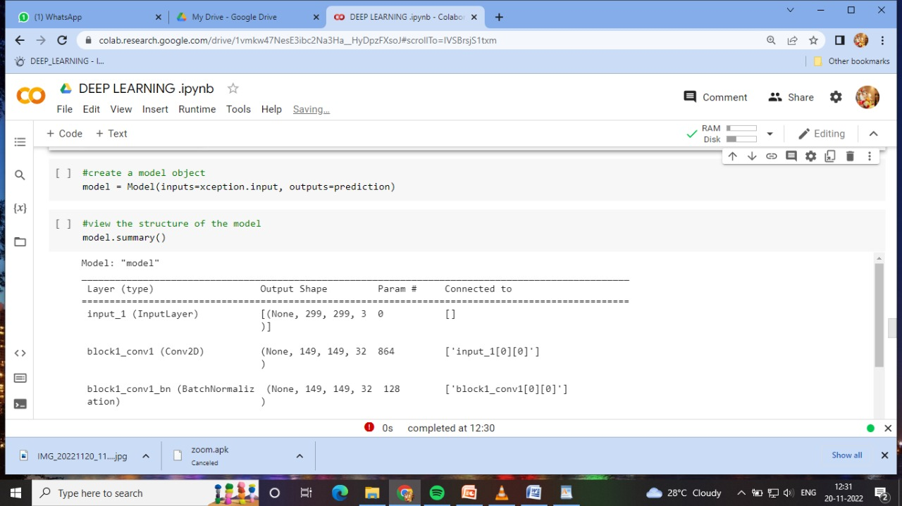

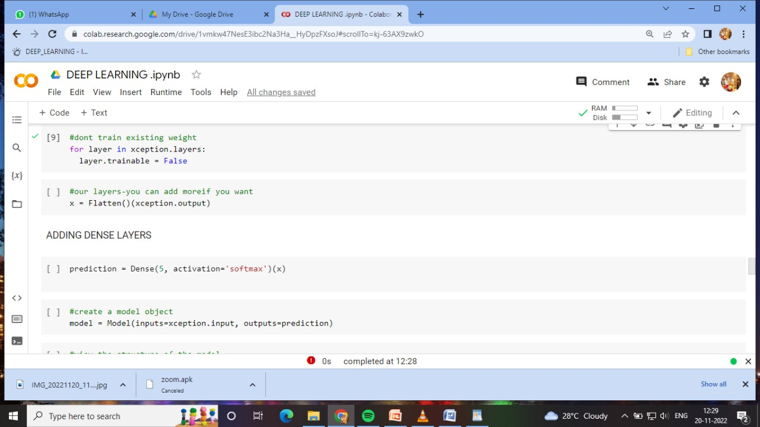

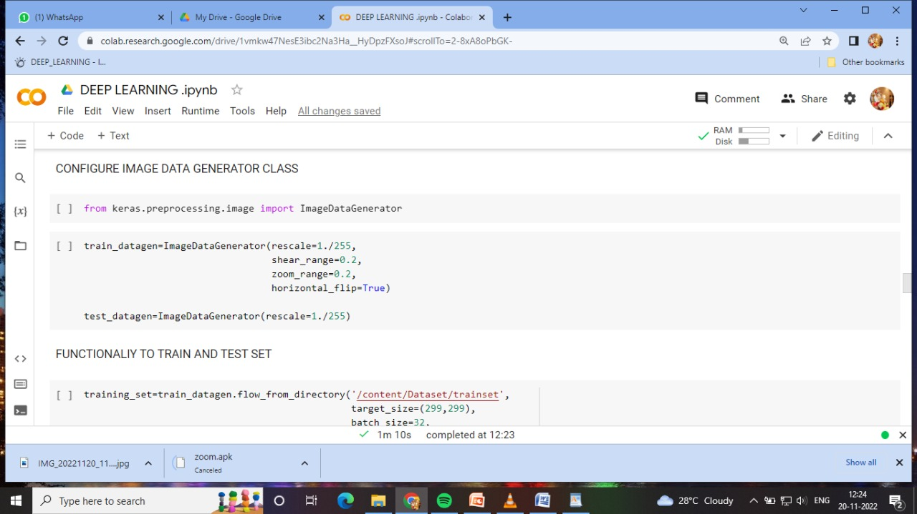

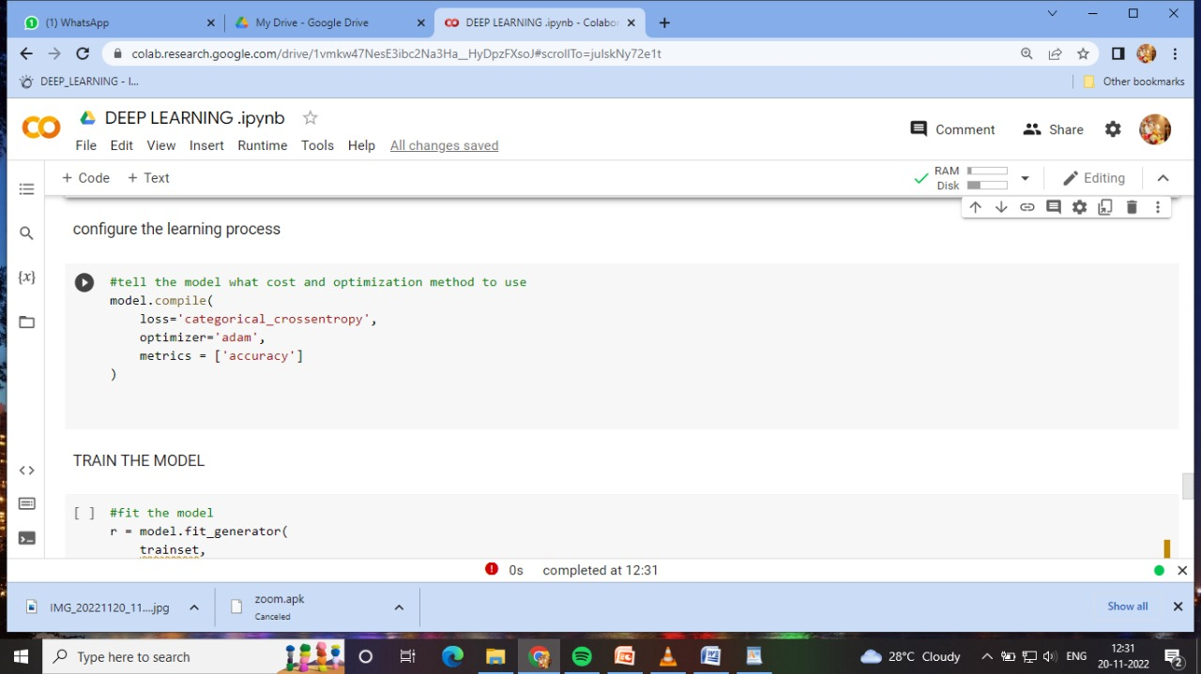

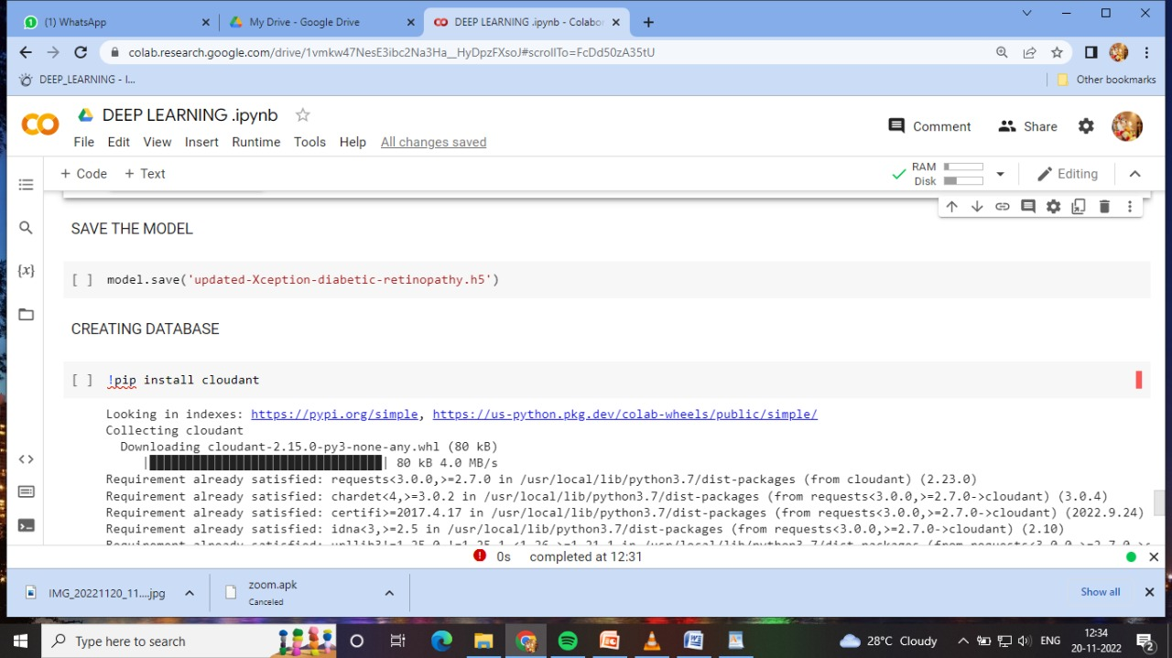

**8.2 User Acceptance Testing:**



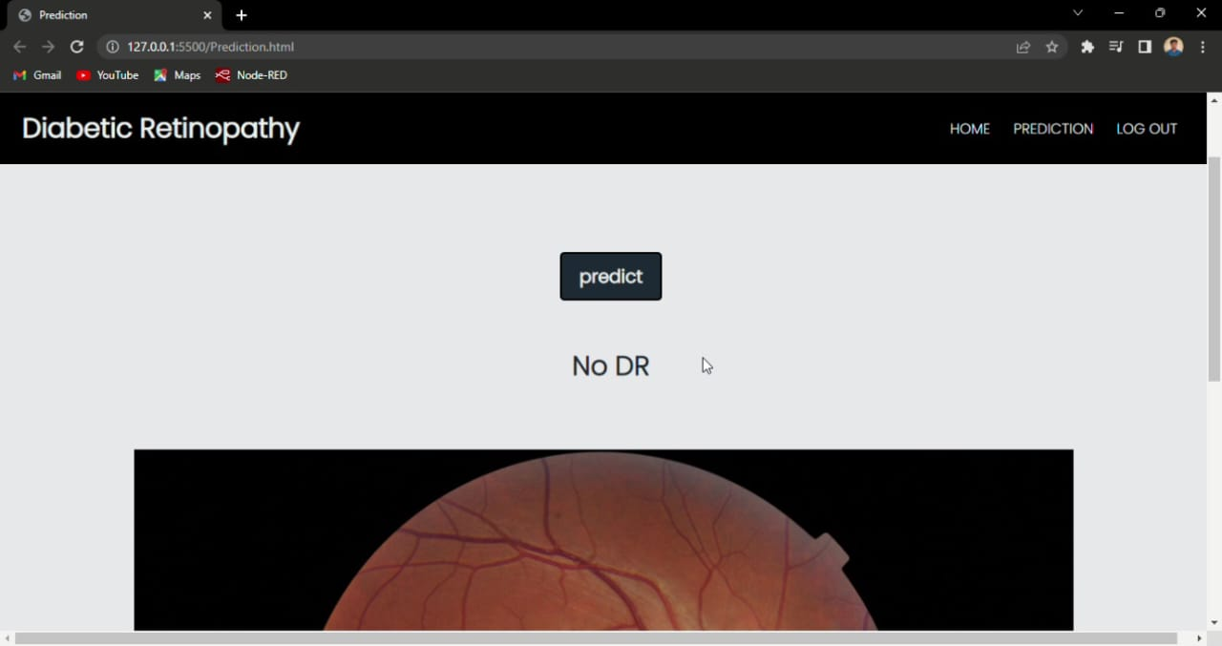

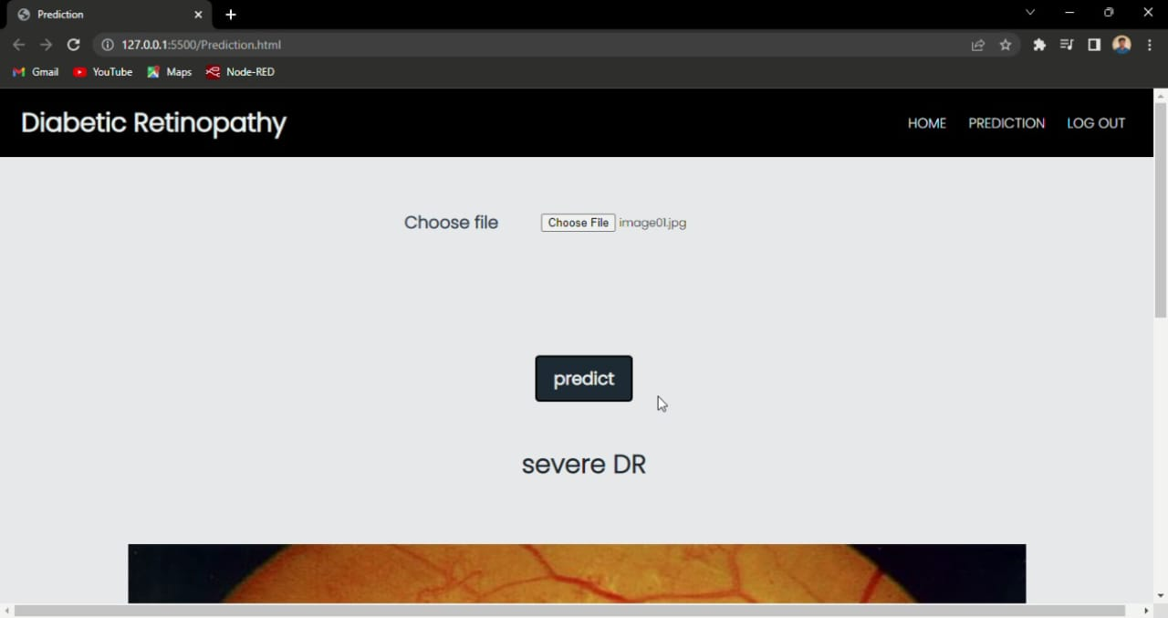

**9.RESULTS**

**10.ADVANTAGES & DISADVANTAGES**

**10.1 Advantages:**

* It significantly reduces the risk of vision loss
* It is a early detection process
* It is time saving process
* Reduce the risk of misdiagnosis
* Using angiographic images ,because of concerns about safety and cost-effectiveness,would prohibit the use of cost-effective large –scale screening.

**10.2 Disadvantages:**

* The datasets are insufficient for diagnosis
* Error in algorithm leads to misdiagnosis
* The cost may be little high
* **The relatively high false positive rate means some patients may have or will soon have a sight –threating eye disease**
* **Individual patient risk of disease severity and vision loss is predicated on disease severity and vision loss is predicated on disease duration ,degree and consistency of metabolic control, and accurate staging of DR.**

**CONCLUSION** :

Deep learning techniques help process and analyze the big data available all around us through systematic programming, disciplines, and codes, to deliver insights and inferences, develop patterns and trends, and for various other applications in several fields.

This indicates that advanced machine learning algorithms such as CNN and ANN perform better than the other classifiers for predicting diabetic retinopathy.

**FUTURE SCOPE :**

New insights into the pathophysiology of diabetes and diabetic retinopathy will improve metabolic control. Structure—function analyses are revealing new details of diabetic retinopathy. Intraocular drug therapy provides improved visual outcomes. Together these steps will yield better means to detect and quantify vision loss, and to develop patient-specific treatments to preserve vision for persons with diabetes.

 Retinopathy is one of the most successfully treated complications of diabetes and will continue to be an important area of research for patients and their families.

**APPENDIX :**

from tensorflow.keras.layers import Dense,Flatten,Input

from tensorflow.keras.models import Model

IMPORTING LIBRARIES

from tensorflow.keras.preprocessing import image

from tensorflow.keras.preprocessing.image import ImageDataGenerator,load_img

from tensorflow.keras.applications.xception import Xception,preprocess_input

from glob import glob

import numpy as np

import matplotlib.pyplot as plt

!pip install tensorflow.gpu

!pip install keras

CONFIGURE IMAGE GENERATOR CLASS

train_datagen=ImageDataGenerator(rescale=1./255,

shear_range=0.2,

zoom_range=0.2,

horizontal_flip=True)

test_datagen=ImageDataGenerator(rescale=1./255)

MODEL BUILDING

xception = Xception(input_shape=imageSize + [3],weights='imagenet',include_top=False)

#dont train existing weight

for layer in xception.layers:

layer.trainable = False

#our layers-you can add moreif you want

x = Flatten()(xception.output)

ADDING DENSE LAYERS

prediction = Dense(5, activation='softmax')(x)

#create a model object

model = Model(inputs=xception.input, outputs=prediction)

#view the structure of the model

model.summary()

CONFIGURE THE LEARNING PROCESS

#tell the model what cost and optimization method to use

model.compile(

loss='categorical_crossentropy',

optimizer='adam',

metrics = ['accuracy']

)

TRAIN THE MODEL

#fit the model

r = model.fit_generator(

trainset,

validation_data=test_set,

epochs=30,

steps_per_epoch=len(training_set)//32,

validation_steps=len(test_set)//32

)

SAVE THE MODEL

model.save('updated-Xception-diabetic-retinopathy.h5')

**DEMO :**

[**https://drive.google.com/file/d/1QG8hbLJEBgmamxTCRNSiABYyBZ5aBC8k/view?usp=share_link**](https://drive.google.com/file/d/1QG8hbLJEBgmamxTCRNSiABYyBZ5aBC8k/view?usp=share_link)